# Kickstarting with Excel #

## Overview of Project ##

Comparing pledge goals to pledge outcomes based on various entertainment categories and time period.

### Purpose ###

The purpose of this report is to address the patterns found between the fundraising goals set versus the outcomes of pledges made. The fundraising team has been able to gather the time of year the pledges are made and finalized, as well as their choice of entertainment, such as photography or theater.

## Analysis and Challenges ##

The bar chart below shows pledge outcome based on the choice of entertainment by the donor. You can see that the theater category has the most pledges made total but has a significant number of failed pledges made. The next biggest category is music. When looking at the total amount donated between these two categories, the highest dollar amount donated by a single donor falls under the music category. The music category may have less pledges made than theater, but they tend to have higher follow through, and larger amounts donated.

It is not clear if the pledges are made right after a showing/event or are made on a whim. There is pledge created and deadline date for each pledge but the time period between each date is not consistent across the board. Some pledges were created 15 days away from the deadline whereas some are months away from the deadline.
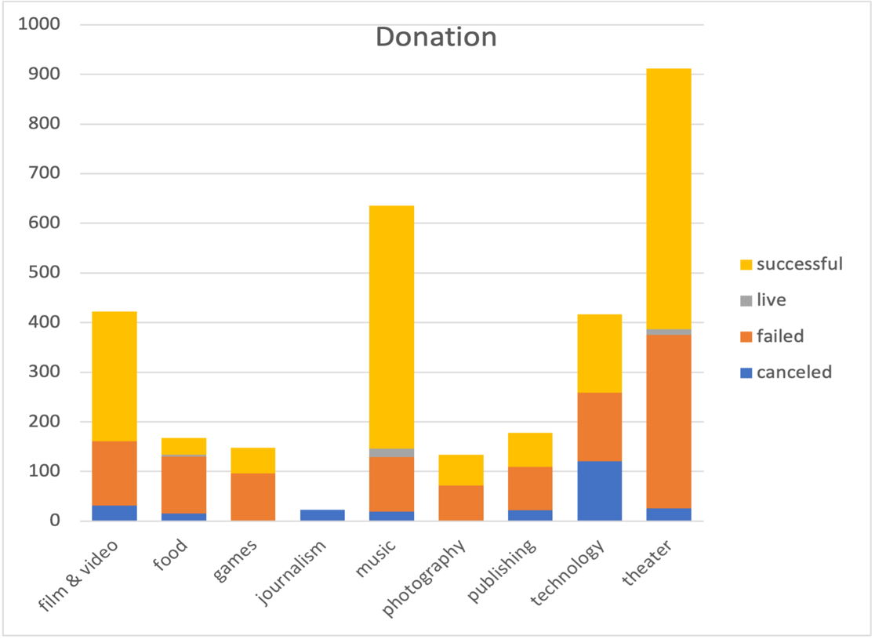

### Analysis of Outcomes Based on Launch Date
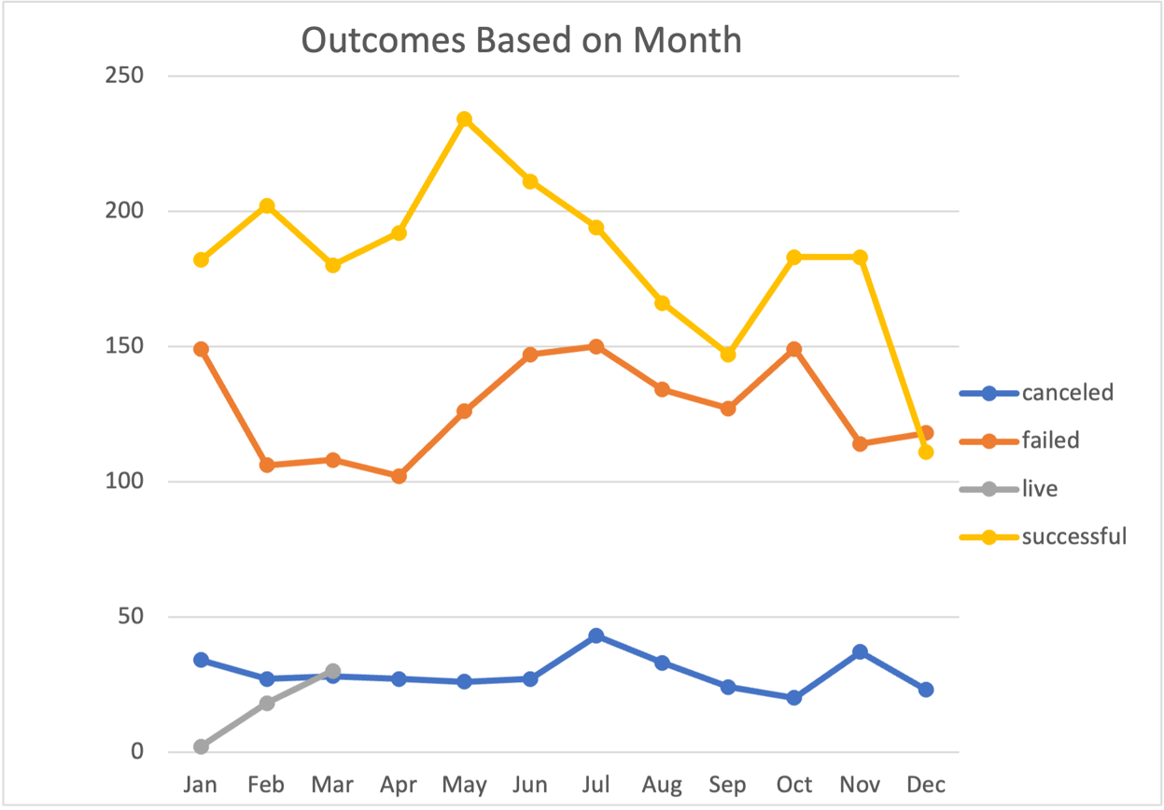
### Analysis of Outcomes Based on Goals
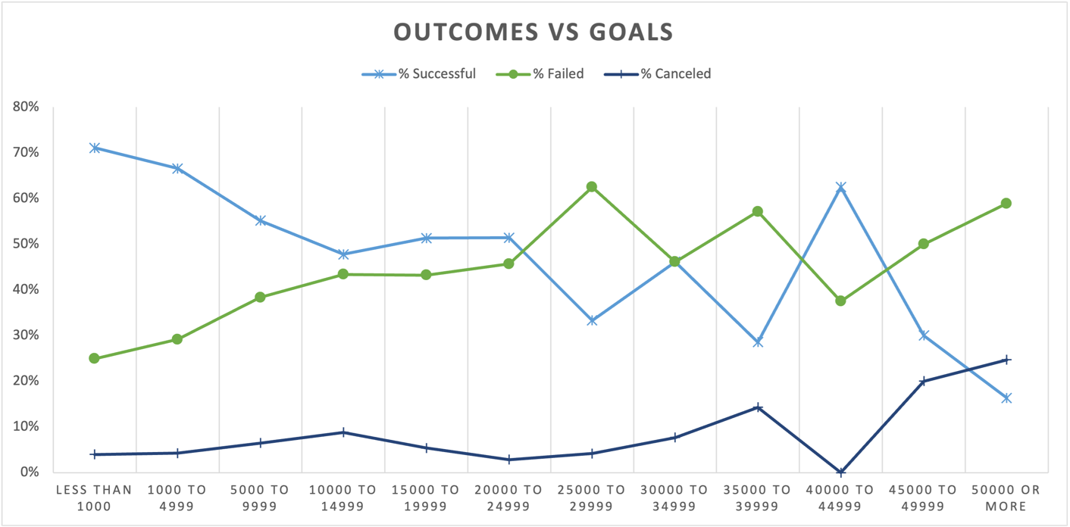

### Challenges and Difficulties Encountered ###

## Results

- What are two conclusions you can draw about the Outcomes based on Launch Date?

The launch dates can show us the strongest month of the year for donations made. We can see that the months of April, May, and June have highest successful donations made. We can also see that there are less failed pledges during these months. This could be that this is a popular season for new releases of shows or books. Schools in the United States begin to close for summer break around May which could mean higher attendance of guests.

When looking over the chart displaying outcomes based on month you can see that there is a downward trend towards as the year begins to end. This could be because those in the United States are preparing for holiday season with family, competing with live performances. This could also mean less funds available during the holiday season to commit to pledges made.

- What can you conclude about the Outcomes based on Goals?

When looking at the line graph displaying the outcomes of pledges made compared to the goals stated you can see that as pledges amount trends higher, the less likely that the full donation is made. This could be due to simple overestimation made at the time of the pledge. It would be nice to get further information on the setting in which the pledges are made so that we can determine the level of pressure that those pledging are under.

- What are some limitations of this dataset?

This data set includes results from different countries but more than 3/4th of the data set is accounting for the United States. It looks like there is some interest from Great Britain which could have potential for the kickstarter program to take off.

- What are some other possible tables and/or graphs that we could create?

We could create a graph using the date the pledge was created and the deadline to search for any significant correlation. It would be interesting to look into a chart comparing the spotlight column with the outcome of the pledges made to see if any particular marketing helped increase donations. I am also curious to see how staff picks would have an influence on fundraising efforts.

